Control algorithm program download and debugging process
In the development process of the experimental test platform, the program download and debugging of the control driver board are completed with the help of j-link simulation downloader. The detailed operation process of program downloads and debugging based on the j-link simulation downloader can be described as follows: first, connect the debugging interface pin of the control drive board with the corresponding pin of the j-link simulation downloader through the DuPont line, and then connect the j-link simulation downloader to the USB port of the upper computer to realize the construction of the hardware communication link. Then complete the driver installation, log in to segger's official website and download the j-link-4.40A driver. Follow the installation wizard provided on the website step by step to ensure the normal adaptation of the driver. Finally, complete the software configuration, configure the debugger parameters in keil/IAR, set the debugger to j-link, select stm32f446ret as the model of the micro control unit, SWD as the debugging interface, and adjust the communication frequency to 10MHz, so as to build the debugging foundation for the algorithm operation of the subsequent stm32f446ret microcontroller and drv8301 smart grid driver chip.
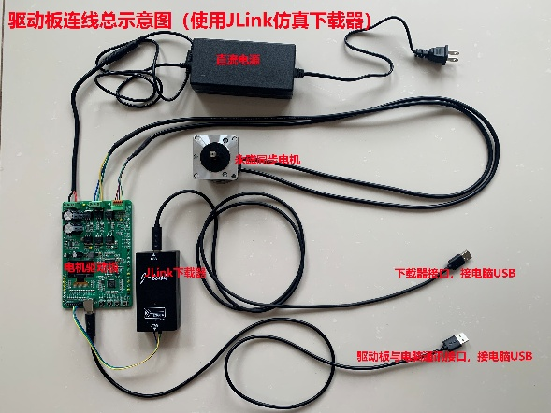
Fig.1. Wiring diagram of control drive board

Environment configuration process
Create a project in Keil: open Keil, click “Project” on the top right, click “New μ vision project”, create a project with any name, and import the folders in GitHub into the new project file in turn. In the new project file, select and click “Options for target”, and the project configuration page as shown in Fig. 2 (a) will pop up, click “Device” in Figure 2 (a), and the page as shown in Fig. 2 (b) will pop up, select the control driver board chip, and click “OK”; Click “C/C++” in Fig 2 (a), and the page shown in Fig 2 (c) will pop up to configure “Define” (here are some mathematical calculation formulas in C++ that need to be introduced into the control algorithm) and “Include Paths” (here is to define the folder path in the new project); Click “Debug” in Fig. 2 (a), and the page shown in Fig. 2 (d) will pop up. After selecting the communication mode (such as J-LINK), click “Settings” button, and the page shown in Fig. 2 (f) will pop up, and select “Port” and “Max”.
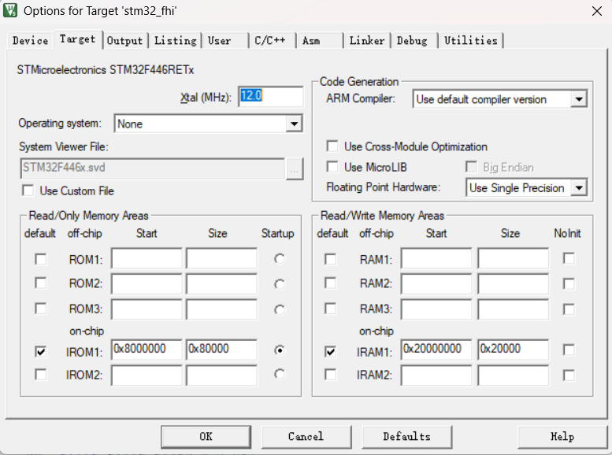
(a)
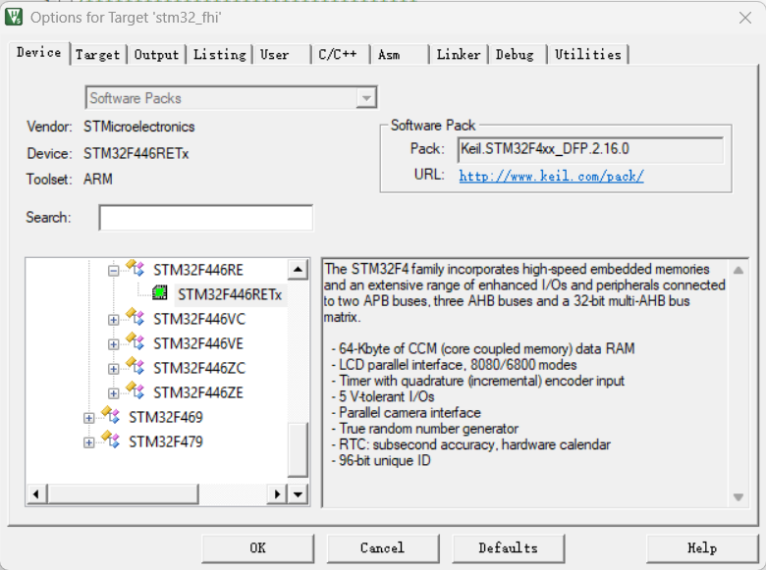
(b)
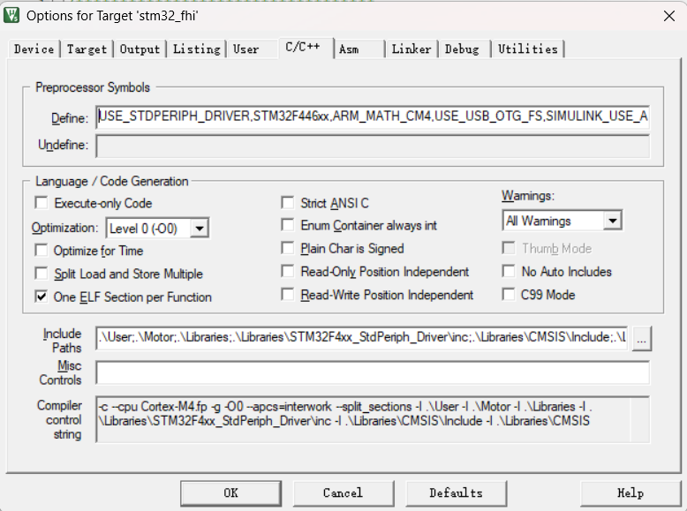
(c)
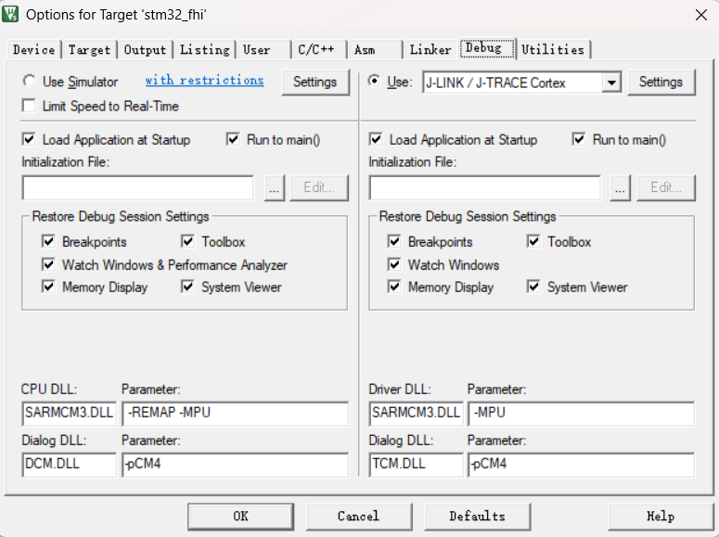
(d)
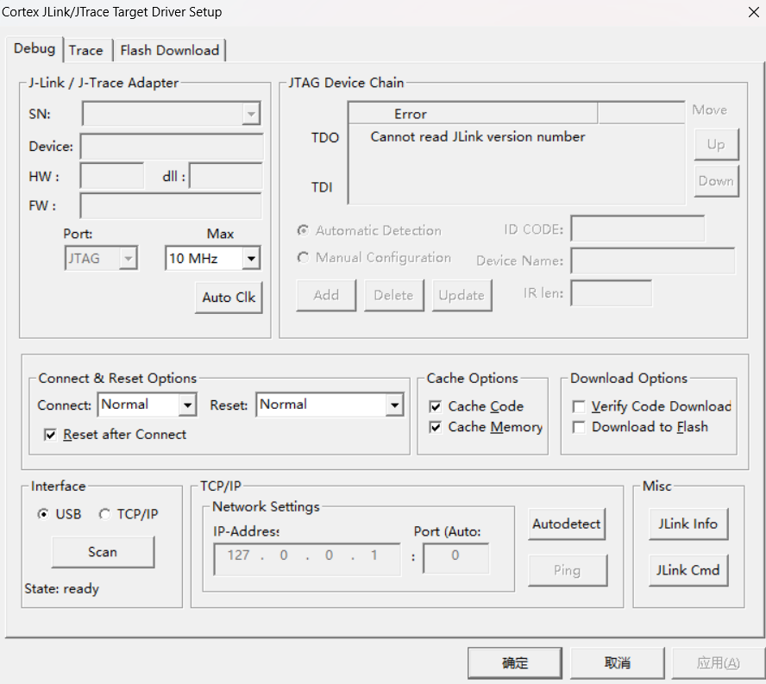
(e)
Fig. 2. Schematic diagram of project configuration page

